**PE**

PE will be with our Sports Coach,Mr Armitage, this term the children will have sessions on a Wednesday afternoon with Swimming every Monday. They will be covering orienteering , cricket and rounders

**Maths**

This term the children will be improving their knowledge of money, time, shape and statistics.

Yr 3 will have an additional topic of fractions

Yr 4 will have an additional topic exploring more decimals, position and direction.

**Geography**

As geographers, we are looking at the countries of the Middle East. 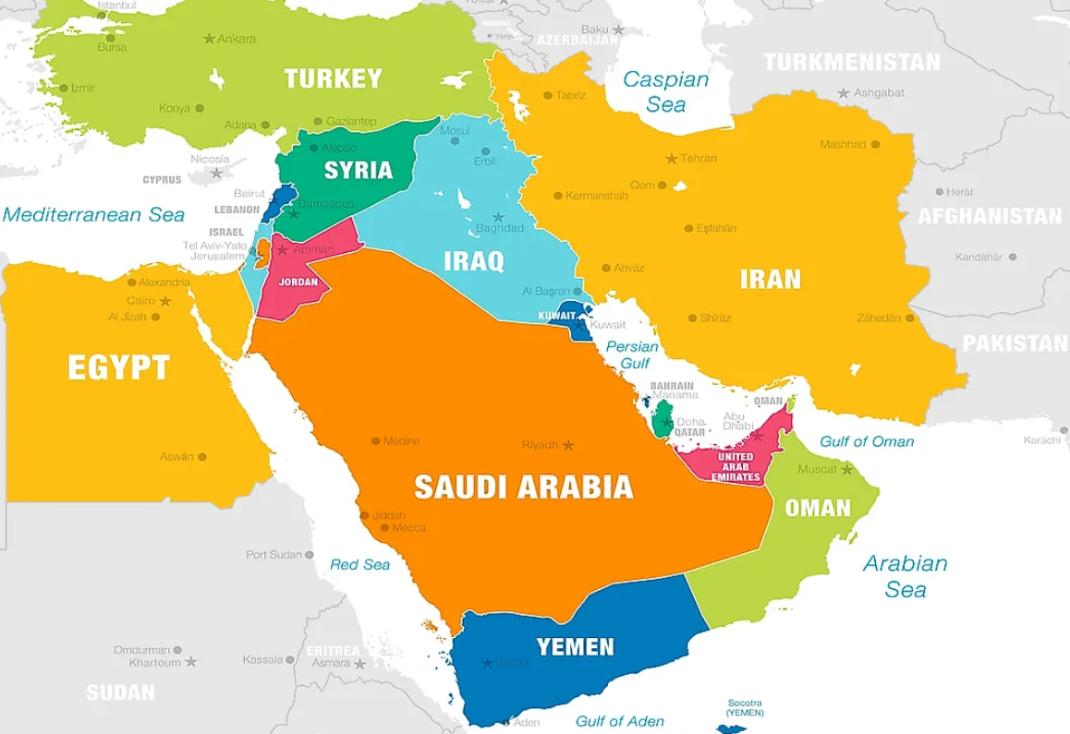

**French**

We are learning how to ask for different flavoured ice creams as well as naming animals .

In English this term we will be exploring tales told in Tents, a collection of stories and poems by Sally Pomme Clayton. We are looking closely at storytelling, reading aloud and performance poetry. Role play elements will be involved with all of the tales from Asian countries. We are continuing with our spelling programme where the children are enjoying the word puzzles and games to solve. Our non-fiction element will be a non-chronological report discovering the Asian countries. In poetry we are using the book Marshmallow Clouds, poems inspired by nature.

Throughout the term, we will continue to practise our grammar, spelling, fluency, comprehension and handwriting skills.

**Design and Technology**

After half term, the class will be exploring shell structures and creating 3d boxes from 2-d drawings. Children will create canopic jars linked to our Ancient Egyptian project.

**Art**

As Artists, we will be looking at the art forms of calligraphy and Middle Eastern design and it’s significance.

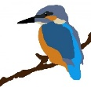

**Music**

As musicians, we will work with Mr Clarke every Friday learning play the Ukuleles. We will learn the cords and notes to play simple songs and perform them to others.

**RE**

As theologists, we are exploring the questions is a Holy Journey necessary for believers? How do Muslims express their faith?

**A Few Reminders**

The children will have PE on a Wednesday they need PE kit in school. Swimming kit for a Monday.

The expectation is that children should be reading for pleasure every night for at least 10 minutes.

Ukuleles will be needed in school every Friday.

**Kingfisher Class**

**Summer Term 2024**

**Spaxton Cof E Primary**

**Science**

As scientists we will be exploring plants and their life cycles, finding out what green plants need to survive, why they have leaves and roots as well, as plant reproduction. 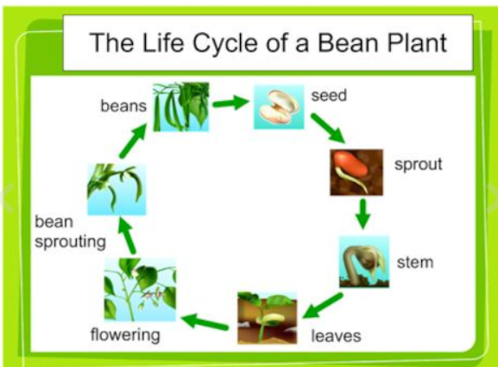

**Computing**

We will be focusing on creating branching keys and databases to classify different objects as well as creating stop frame animations.

**History and Geography**

We will be focusing on Ancient Egypt. Egyptian life, religion and culture in these fascinating times.

