**Geography**

As geographers, we will be focusing on the Space Race and exploring the countries of Russia and the USA. We will begin by exploring what the Space Race is and then move on to looking at each of the countries involved in the race. Throughout the topic we will be looking at the physical characteristics of the countries and reflecting on the impact of those on the suitability for a rocket launch site. We will finish the topic by becoming astronauts and picking another suitable site for a rocket launch based on the all that we have learned.

**RE**

As theologists, this term we will be exploring the key question ‘Does it matter what we believe about Creation’. We will be taking part in debates on topics such as who is responsible for our planet and what should we be doing to protect our planet. Throughout the topic we will be looking at the Christian story of creation as well as other faiths’ stories and will be making comparisons between them.

**Music**

As musicians, will be listening and responding to a range of music this term. They will learn to sing a range of songs and perform them with accompanying instruments.

**Art**

As Artists, we will be looking at increasing our skills of drawing and painting through investigating the artist Chelsey Bonestell. We will continue to develop our sketch books using a range of media.

**Computing**

As programmers, we are learning about network systems and how modern day devices such as Amazon collection lockers work.

**French**

As linguists, we are learning to describe the planets and preparing for an interview as an astronaut going into space!

**English**

In English we will be exploring the novel Cosmic by Frank Cottrell Boyce (linking this to our Science sessions). This will be used as a stimulus to create a non-chronological text linked to space, as well as persuasion pieces of writing. Whilst looking at these text types, we will be looking at identifying different word classes, use of fronted adverbials as well as developing our use of punctuation. We will also be developing our narrative writing by looking at applying our use of description to paint a vivid picture of characters and settings.

Throughout the term, we will continue to practise our grammar, spelling, fluency, comprehension and handwriting skills.

**A Few Reminders**

The children will have PE on a Monday and Friday so they need school PE kit in for these days.

Multiskills is available on a Wednesday after school.

The expectation is that children should be reading for pleasure every night for at least 10 minutes.

**History**

We will be focusing on our history topic of the Stone Age after half term. As historians, the children will be looking at placing this era on a time line. We will be looking at Europe in the Stone Age and be using a range of historical enquiry skills in order to answer questions about life at this time.

**PE**

PE will be with our Sports Coach, Mr Anning, this term. The children will have sessions on a Monday and Wednesday.

**Maths**

This term the children will be improving their knowledge of addition, subtraction, multiplication and division, as well as their understanding, rounding and place value of numbers to 1,000,000 and beyond. They will develop their understanding of these topics through a range of fluency, reasoning and problem solving activities whilst extending their use of correct mathematical terminology.

Later in the term, we will move into learning about fractions, where the children will develop their confidence with simplifying, ordering and comparing fractions.

**Design and Technology**

After half term, the children will become designers in the making. They will be using their skills to design, make and create a object linked to a Christmas gift.

**Peregrine Class**

**Autumn Term 2023**

**Spaxton Cof E Primary**

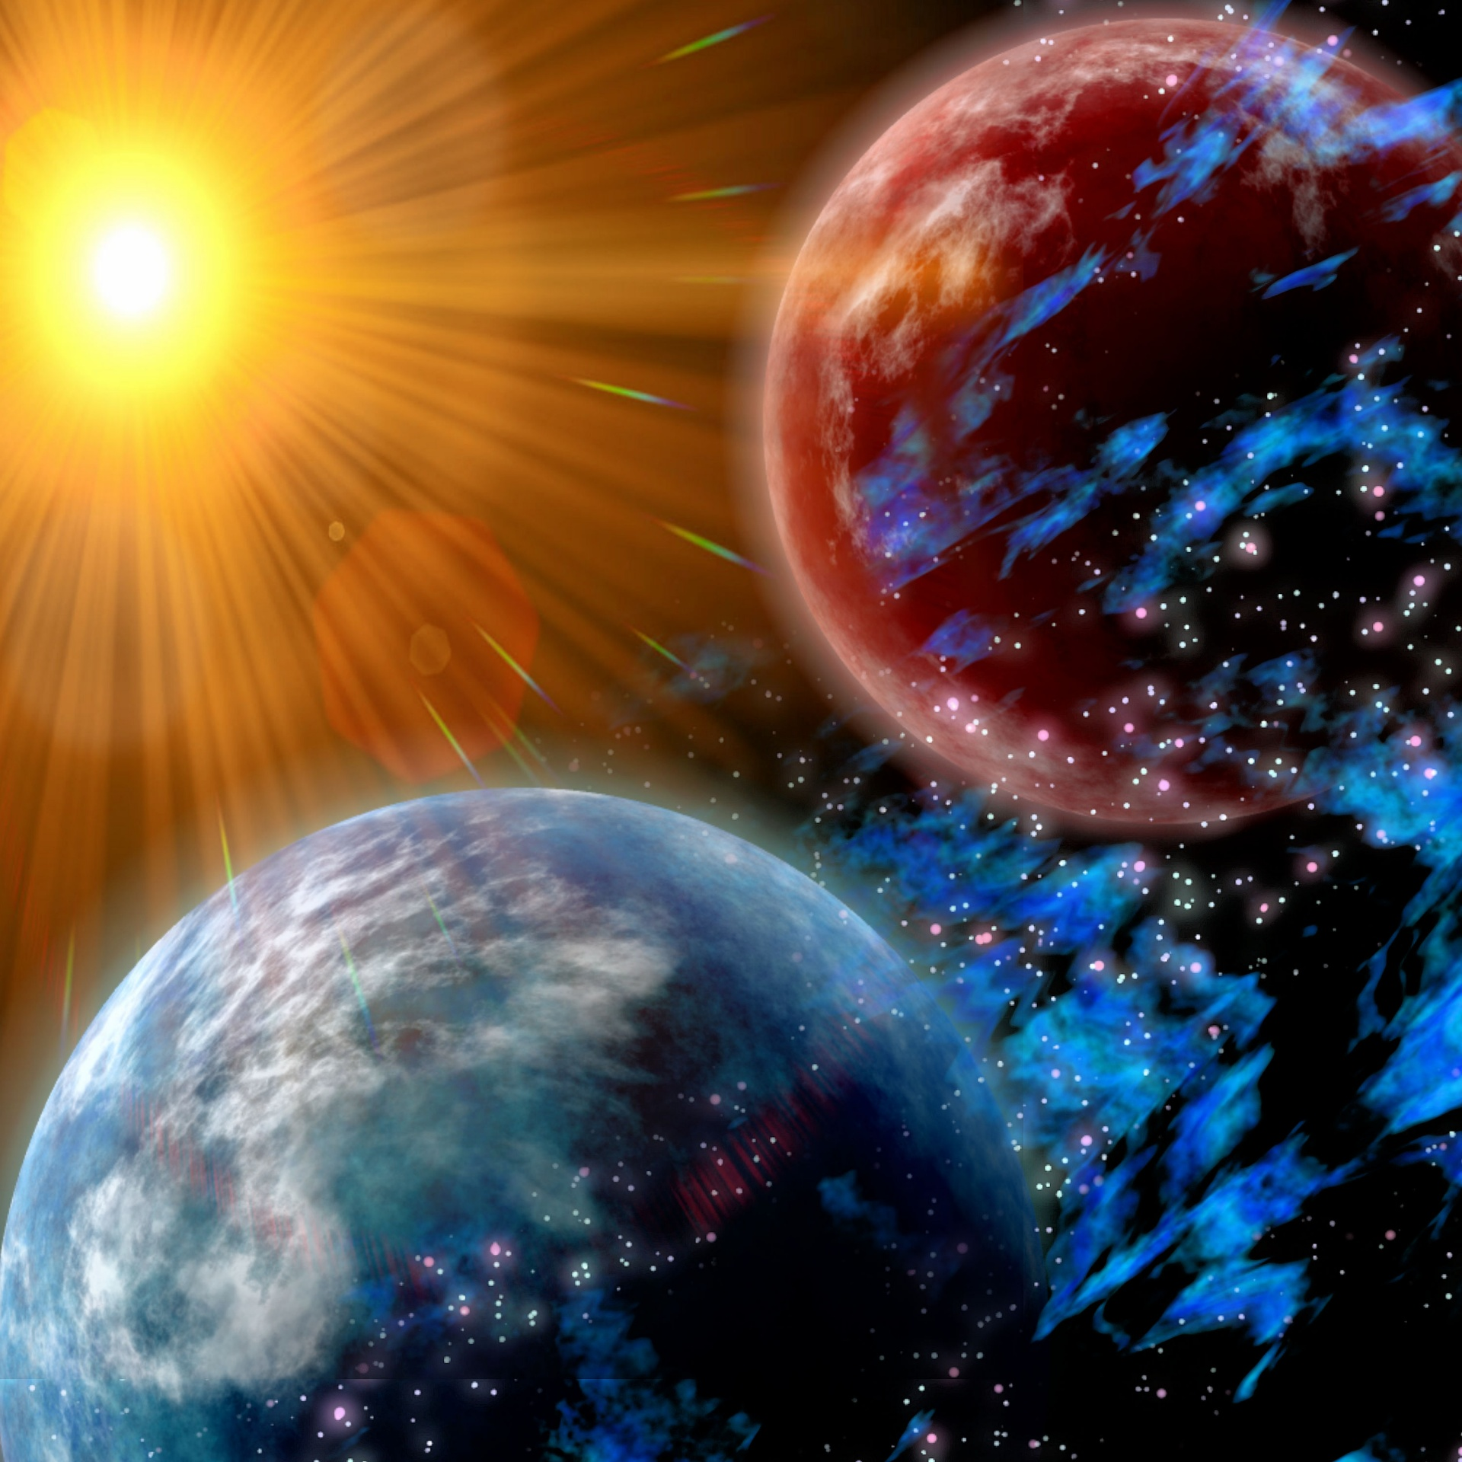

Space

**Space**

**Science**

As scientists we will be investigating Space this term. We will start by looking at the children’s prior knowledge before setting the task of filling in a moon diary to look for patterns over time. We will return to looking at their diaries in order to draw conclusions from their results.

The children will investigate the solar system and secure their understanding of it. They will be able to explain why we have day and night as well as understand the formation of constellations